

**Report Title**: Text to Binary Conversion

**Department**: Computer Science and Engineering

**Course Title**: Data Communication (LAB)

**Course Code**: CSE-304

**Course Teacher**:

Dr. M. Firoz Mridha

Assistant Professor and Coordinator MCSE

University of Asia pacific.

**Submitted By:**

Md Mehedi Hasan

ID: 16201073

Sec: A2

**Project No:** 1

**Project Name:** Text to Binary Conversion using Python.

Objectives: To Learn Basic Representation of Data in Computer Memory by Converting Text into Binary.

**Programming Language:**

I use Python programming language to complete this project

**Python Library:**

I use binascci library of python programming for text to binary conversion.

**Requirements:**

* Python2.7
* IDLE
* Windows 7/8/10 Operating System.

**Algorithm:**

Step 1: Start IDLE

Step 2: Import binascii

Step 3: Declare Variable (text) and Take raw input from user

Step 4: Print user given string

Step 5: Convert string to binary using “Join” function

Step 6: Print the Binary Representation

**Flowchart:**

START

**Variable Declare & Take Input**

**text = raw_input()**

**END**

**Convert Text To Binary**

**' '.join(format(ord(x), 'b') for x in text)**

**Print Binary**

**Code & Screenshot:**

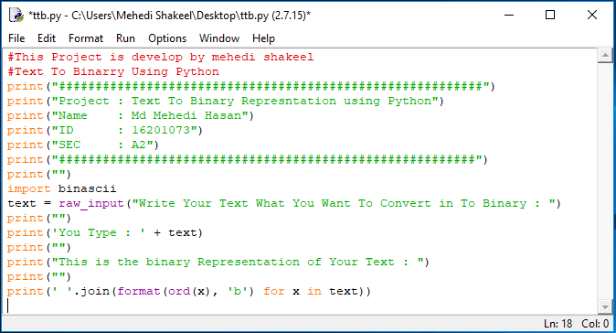

**Output:**

